Expired Sweetness Game Design Document (GDD)

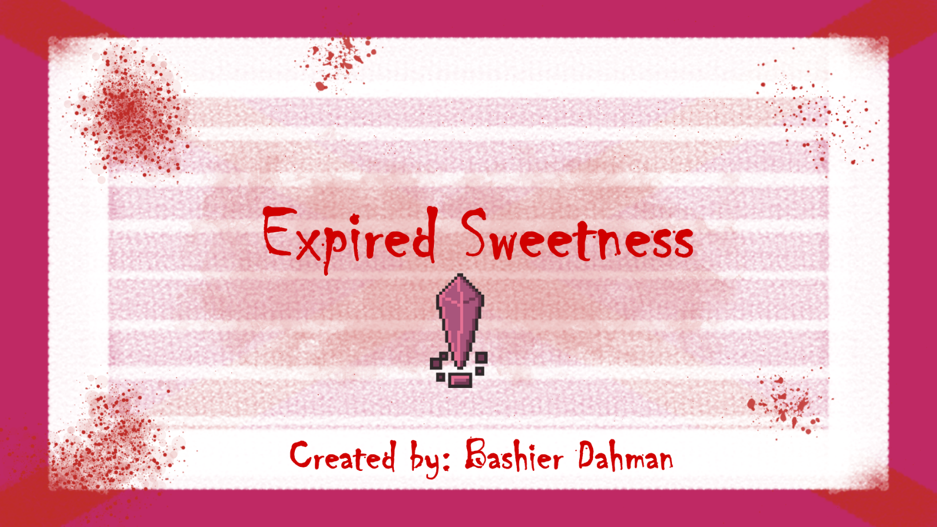

***‘Better bring a sweet tooth’*** – Bashier Dahman

This page: Table of Contents and Team Member Listing

|  |  |  |
| --- | --- | --- |
| Table of Contents  [1 Game Overview](https://n-xovwktmtjsnaxyc2mwes2xu7pohqedmdm6zjw5q-2lu-script.googleusercontent.com/userCodeAppPanel)  [2 High Concept](https://n-xovwktmtjsnaxyc2mwes2xu7pohqedmdm6zjw5q-2lu-script.googleusercontent.com/userCodeAppPanel)  [3 Unique Selling Points](https://n-xovwktmtjsnaxyc2mwes2xu7pohqedmdm6zjw5q-2lu-script.googleusercontent.com/userCodeAppPanel)  [4 Platform Minimum Requirements](https://n-xovwktmtjsnaxyc2mwes2xu7pohqedmdm6zjw5q-2lu-script.googleusercontent.com/userCodeAppPanel)  [5 Competitors / Similar Titles](https://n-xovwktmtjsnaxyc2mwes2xu7pohqedmdm6zjw5q-2lu-script.googleusercontent.com/userCodeAppPanel)  [6 Synopsis](https://n-xovwktmtjsnaxyc2mwes2xu7pohqedmdm6zjw5q-2lu-script.googleusercontent.com/userCodeAppPanel)  [7 Game Objectives](https://n-xovwktmtjsnaxyc2mwes2xu7pohqedmdm6zjw5q-2lu-script.googleusercontent.com/userCodeAppPanel)  [8 Game Rules](https://n-xovwktmtjsnaxyc2mwes2xu7pohqedmdm6zjw5q-2lu-script.googleusercontent.com/userCodeAppPanel)  [9 Game Structure](https://n-xovwktmtjsnaxyc2mwes2xu7pohqedmdm6zjw5q-2lu-script.googleusercontent.com/userCodeAppPanel)  [10 Game Play](https://n-xovwktmtjsnaxyc2mwes2xu7pohqedmdm6zjw5q-2lu-script.googleusercontent.com/userCodeAppPanel)  [10.1 Game Controls](https://n-xovwktmtjsnaxyc2mwes2xu7pohqedmdm6zjw5q-2lu-script.googleusercontent.com/userCodeAppPanel)  [10.2 Game Camera](https://n-xovwktmtjsnaxyc2mwes2xu7pohqedmdm6zjw5q-2lu-script.googleusercontent.com/userCodeAppPanel)  [10.2.1 HUD](https://n-xovwktmtjsnaxyc2mwes2xu7pohqedmdm6zjw5q-2lu-script.googleusercontent.com/userCodeAppPanel)  [11 Players](https://n-xovwktmtjsnaxyc2mwes2xu7pohqedmdm6zjw5q-2lu-script.googleusercontent.com/userCodeAppPanel)  [11.1 Characters](https://n-xovwktmtjsnaxyc2mwes2xu7pohqedmdm6zjw5q-2lu-script.googleusercontent.com/userCodeAppPanel)  [11.2 Metrics](https://n-xovwktmtjsnaxyc2mwes2xu7pohqedmdm6zjw5q-2lu-script.googleusercontent.com/userCodeAppPanel)  [11.3 States](https://n-xovwktmtjsnaxyc2mwes2xu7pohqedmdm6zjw5q-2lu-script.googleusercontent.com/userCodeAppPanel)  [11.4 Weapons](https://n-xovwktmtjsnaxyc2mwes2xu7pohqedmdm6zjw5q-2lu-script.googleusercontent.com/userCodeAppPanel)  [12 Player Line-up](https://n-xovwktmtjsnaxyc2mwes2xu7pohqedmdm6zjw5q-2lu-script.googleusercontent.com/userCodeAppPanel)  [13 NPC](https://n-xovwktmtjsnaxyc2mwes2xu7pohqedmdm6zjw5q-2lu-script.googleusercontent.com/userCodeAppPanel)  [13.1 Enemies](https://n-xovwktmtjsnaxyc2mwes2xu7pohqedmdm6zjw5q-2lu-script.googleusercontent.com/userCodeAppPanel)  [13.1.1 Enemy States](https://n-xovwktmtjsnaxyc2mwes2xu7pohqedmdm6zjw5q-2lu-script.googleusercontent.com/userCodeAppPanel)  [13.1.2 Enemy Spawn Points](https://n-xovwktmtjsnaxyc2mwes2xu7pohqedmdm6zjw5q-2lu-script.googleusercontent.com/userCodeAppPanel)  [13.2 Allies / Companions](https://n-xovwktmtjsnaxyc2mwes2xu7pohqedmdm6zjw5q-2lu-script.googleusercontent.com/userCodeAppPanel)  [13.2.1 Ally States](https://n-xovwktmtjsnaxyc2mwes2xu7pohqedmdm6zjw5q-2lu-script.googleusercontent.com/userCodeAppPanel)  [13.2.2 Ally Spawn Points](https://n-xovwktmtjsnaxyc2mwes2xu7pohqedmdm6zjw5q-2lu-script.googleusercontent.com/userCodeAppPanel)  [14 Art](https://n-xovwktmtjsnaxyc2mwes2xu7pohqedmdm6zjw5q-2lu-script.googleusercontent.com/userCodeAppPanel)  [14.1 Setting](https://n-xovwktmtjsnaxyc2mwes2xu7pohqedmdm6zjw5q-2lu-script.googleusercontent.com/userCodeAppPanel)  [14.2 Level Design](https://n-xovwktmtjsnaxyc2mwes2xu7pohqedmdm6zjw5q-2lu-script.googleusercontent.com/userCodeAppPanel)  [14.3 Audio](https://n-xovwktmtjsnaxyc2mwes2xu7pohqedmdm6zjw5q-2lu-script.googleusercontent.com/userCodeAppPanel)  [15 Minimum Viable Product (MPV)](https://n-xovwktmtjsnaxyc2mwes2xu7pohqedmdm6zjw5q-2lu-script.googleusercontent.com/userCodeAppPanel)  [16 Wish List](https://n-xovwktmtjsnaxyc2mwes2xu7pohqedmdm6zjw5q-2lu-script.googleusercontent.com/userCodeAppPanel)  17 Bibliography   |  | | --- | |  | | Game Development Team Members    PRODUCER  Bashier Dahman    PRODUCTION MANAGER  Bashier Dahman    PRODUCTION COORDINATOR  Bashier Dahman  GAME DESIGNERS  Bashier Dahman  SYSTEMS/IT COORDINATOR  Bashier Dahman  PROGRAMMERS  Bashier Dahman  TECHNICAL ARTISTS  Bashier Dahman  AUDIO ENGINEERS  Bashier Dahman  UX TESTERS  Bashier Dahman |

|  |
| --- |
|  |

# 1 Game Overview

Title: Expired Sweetness

Platform: PC / Mac

Genre: Action – Adventure / Inspired by Charlie & the Chocolate Factory

Rating: Everyone 10+

Target: Casual gamer

Release date: November, 2020

Publisher: Bash Cash Gaming

Expired Sweetness is a third-person 2D Action / Adventure game inspired by Charlie and the Chocolate Factory with a hint of drama and action.

You play as Tootsie Mike, a millionaire who runs a multi-million-dollar candy company. Ever since you inherited “Sweet World” (your company’s name), everything has always been smooth sailing. Your employees have always been loyal ever since your father built the company. These small yet cheerful little “dumplings” always did their work on time and never skipped a day.

Yet one day, a few disgruntled employees release expired candy furious at you for paying your workers solely in candy. Claiming they have no way of supporting their family with just chocolate bars. The audacity.... This candy, “Yum Tum”, when left expired, creates a chemical reaction forming the infectious disease called “Mad Tum Disease”. It is up to you to find all the poisonous / expired candy and dispose of them correctly. Not only that but your final main objective is to retrieve the vaccine needed for this virus. Be wary of the disgruntled employees, as they’re your enemy. You will find friends and foes in this quest; the entire fate of the world will be in your hands.

# 2 High Concept

Expired Sweetness sets the Player in the factory where the expired sweets were dispersed. You must retrieve all expired candy before the next shipment of sweets is sent out and the virus can plague the Earth. Along your way you will meet fellow loyal workers, disgruntled employees, and even infected employees who have tasted the “Expired Sweetness”.

# 3 Unique Selling Points

* Fun, yet dramatic
* Unique twist to a famous story
* Creative art

# 4 Platform Minimum Requirements

OS: Windows XP SP2+, Mac OS X 10.8+

# 5 Competitors / Similar Titles

Competitors to this game would be any 2D platformer game with adventure and enemy NPC’s. A similar title to this game would be the classic Super Mario games.

# 6 Synopsis

Due to Tootsie Mike’s subconscious greed, he has created a group of displeased employees set out to destroy the world under his name. It is up to you to help Tootsie understand his mistakes and save the world

# 7 Game Objectives

The main objective of the game is to find all the expired candy and to also locate the vaccine for the “Mad Tum Disease”.

# 8 Game Rules

The game is a closed environment set in Sweet World’s factory. The player, who controls Tootsie Mike (the main character), will be able to use a sword placed inside the game. The user will also be able to pick up the expired sweets and be able to dispose of them. The total amount of expired candies scattered throughout the game level is 10. There are also two types of NPCs, friendly NPCs and enemy NPCs. The friendly NPCs will help and guide you along the way, while the enemy NPCs are out to make sure you don’t make it to the vaccine.

Not only that, the difficulty of the game increases as you continue on throughout the level. The entirety of the bottom floor consists of spikes which can ultimately end the game for the player, causing them to restart from the beginning. As the player progresses, more platforms will start to move as well, one wrong slip and they’re all the way back at square 1. This causes the player to be more cautious and slow down.

# 9 Game Structure

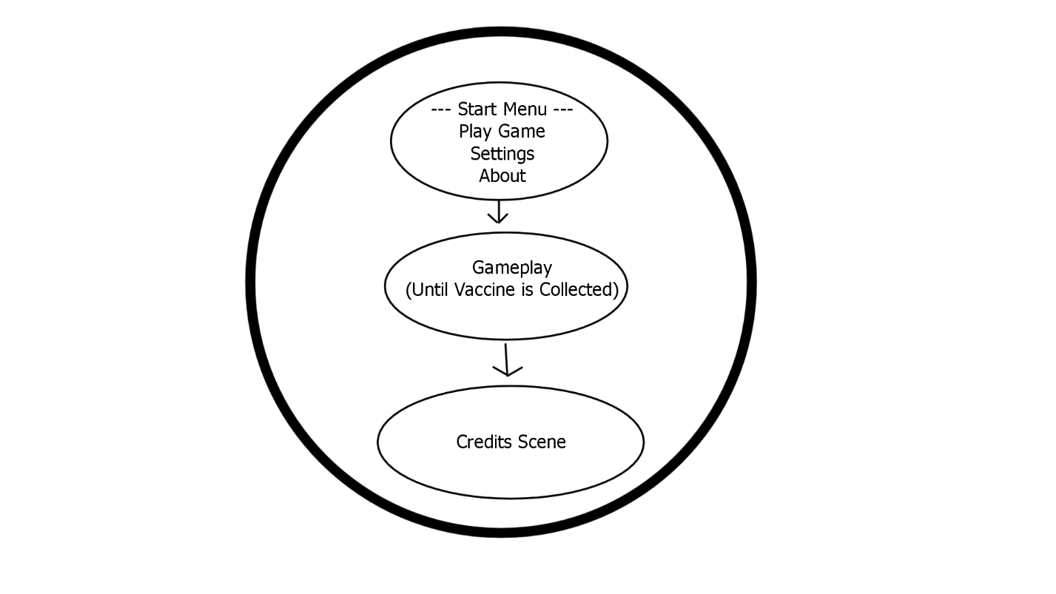

# 10 Game Play

## 10.1 Game Controls

The controls to play this game are “W / D and Left / Right arrows to move left & right”. Space bar to Jump. “E” to equip Sword, “P” pick up candies / dispose of them, “J” to collect vaccine, “M” to slash your sword to the right, “N” to slash your sword to the left.

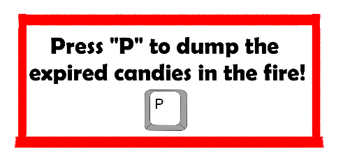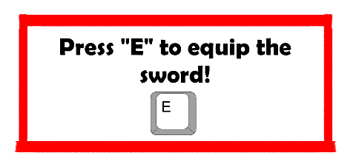

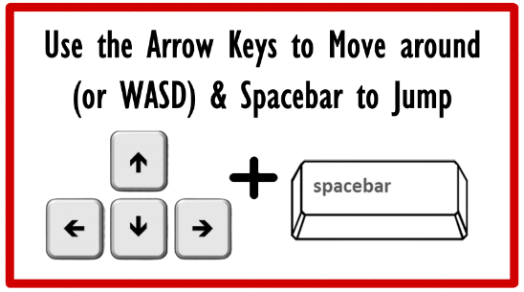

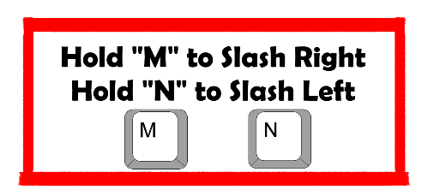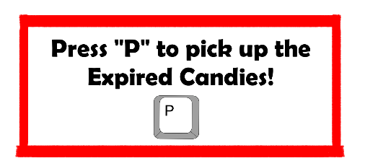

## 10.2 Game Camera

The game camera follows the character as he traverses through the scene. It stays fixated on his position.

### 10.2.1 HUD

The HUD consists of the player, the amount of candy they’ve collected, the amount of hearts they have (basically player lives)

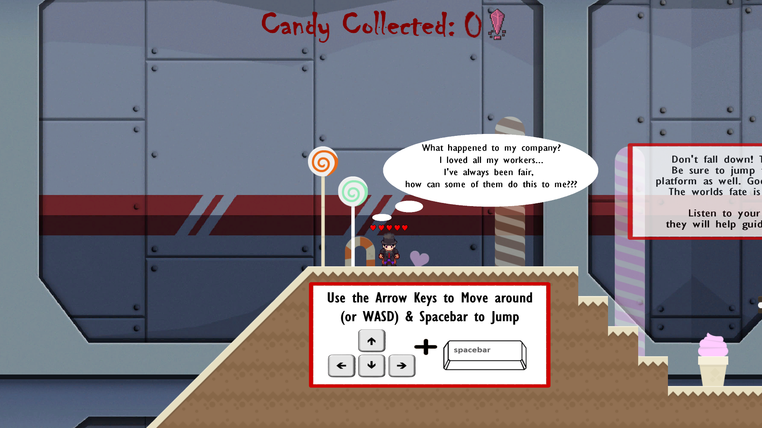

# 11 Players

## 11.1 Characters

The main character the user plays as is, Tootsie Mike, a very rich and successful man.

## 11.2 Metrics

Player 🡪 Speed: 3, Health: 5, Jumping Height: 5.5, Attack Damage: 2, Attack Range: 0.65

## 11.3 States

Idle: The Idle State is a cycled animation where the player is moving in place, fairly subtle.

Move: There’s two separate animations for moving to the left and right, this is triggered when the play presses either of the keys to move to the left/right.

NOTE: There are separate idle and walking animations dependent on if the user has equipped the sword or not.

Jump: The Jump animation will be triggered when the user presses the Jump key.

Slash Left/Right: The slash animation will cause the player to swing his sword either to the left or to the right.

Death: The death animation will make the player fall to the ground. There are two separate animations once again, both dependent on whether the player has equipped the sword or not.

NOTE: The game over background will pop up when the user dies, this was added to make the restart / main menu buttons become clearer. This unfortunately hides the death animation, but nonetheless it still plays.

## 11.4 Weapons

The sword is equipped by the player himself and this allows him to slash enemies and includes the proper animations. The damage the sword does is: 2.

# 12 Player Line-up

WITHOUT SWORD



WITH SWORD



# 13 NPC

## 13.1 Enemies

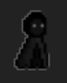

The infected “dumpling” has a max health of 50. It’s move speed is 0.20 and if the player is touched by it, it will knock off one heart.

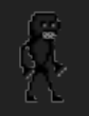

This enemy NPC is nicknamed the “Behemoth”, it is considered the boss in the game. Max health for the behemoth is 350, and the speed is 0.1. Its attack damage is still the same as the dumpling, as it takes a lot longer to kill. Knocking off one heart every time it makes contact with the player. The player has to approach this NPC with tactics as they try to avoid contact with it.

### 13.1.1 Enemy States

All enemies possess the same behavior and states, as described below:

Movement: The enemies will constantly be moving back and forth from each of their respective Way Points.

Death: When the player deals enough damage to the enemy, the enemy will produce an explosion animation and disappear.

### 13.1.2 Enemy Spawn Points

Each enemy object is spawned in their respective places as soon the game begins.

## 13.2 Allies / Companions

### 

The two types of Allies in this game are both “dumplings”, neither are infected nor can be interacted with. They simply guide the player on what to do in the game, and help him collect / dispose of the infected candies.

### 13.2.1 Ally States

The allies are a part of the game’s scenes, they do not move nor can be interacted with. They maintain the same idle state and only have a chat bubble to guide the player throughout the game.

### 13.2.2 Ally Spawn Points

The Allies are spawned in their respective places as soon as the scene is loaded, just like the Enemy NPCs.

# 14 Art

Main Menu Scene:

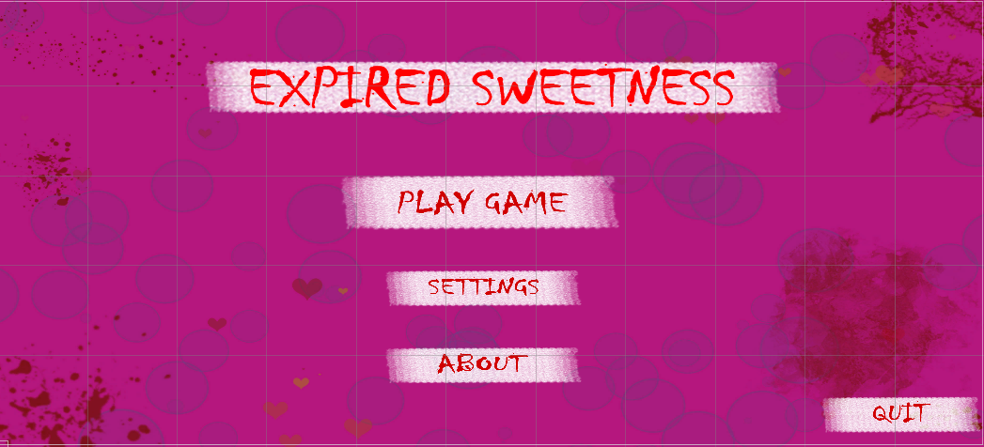

Settings Scene:

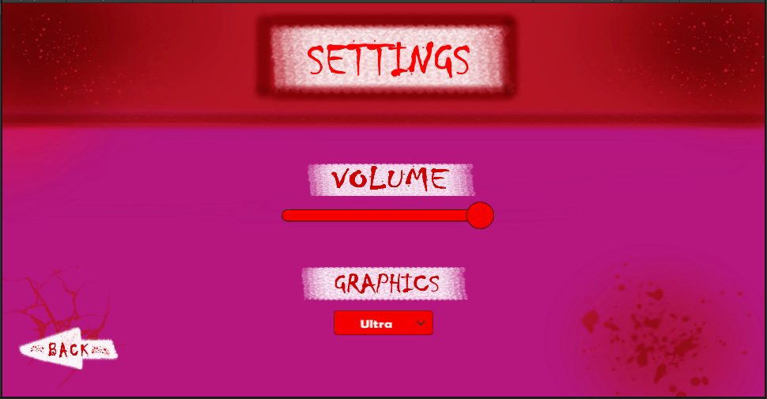

About Scene:

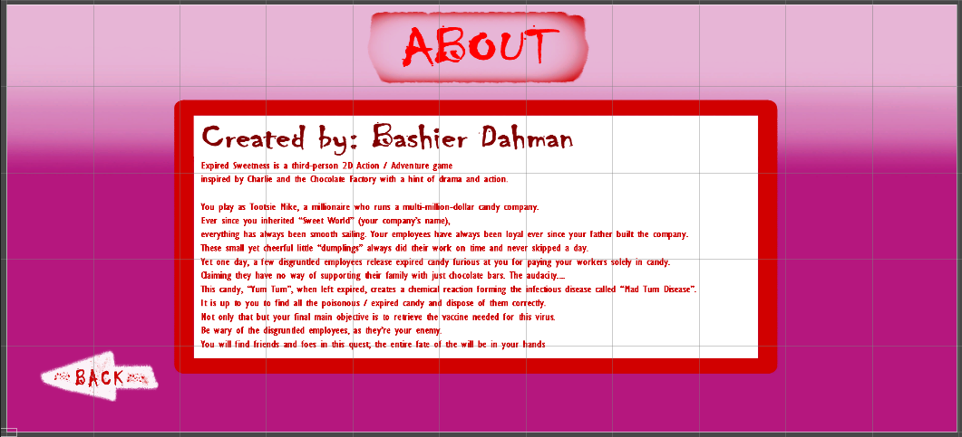

## 14.1 Setting

The game takes place in the “Sweet World” Factory. Because of this the background has a mixture of factory setting and sweets.



## 14.2 Level Design

The level consists of the platforms, spikes, candy ground, infected ground, moving platforms, and obstacles such as trees and candy are also scattered throughout the level.

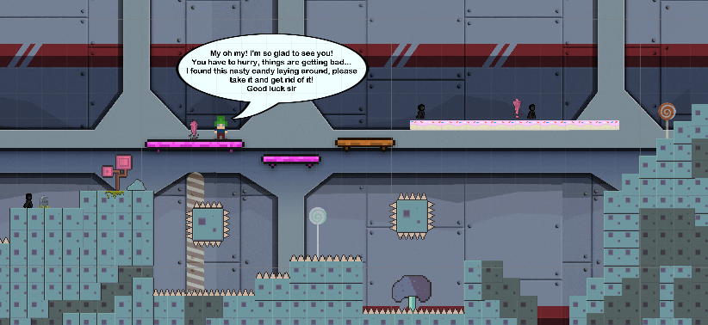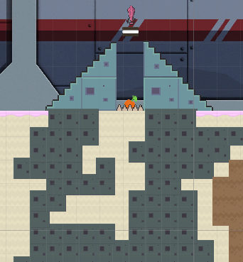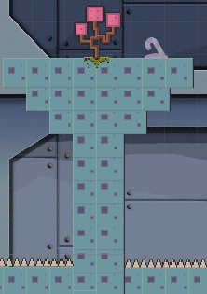

## 14.3 Audio

|  |  |  |
| --- | --- | --- |
| NAME | CATEGORY | DESCRIPTION |
| Alexander Ehlers – Flags | Background Music | Plays during the game |
| 109414__black-snow__sword-slice-05 | FX | Sword Equip Sound |
| 320655__rhodesmas__level-up-01 | FX | Vaccine Pick up, Victory Sound |
| Bonus | FX | When Player picks up a candy |
| DeathVoice | FX | When Players kills the Boss, the boss makes this sound |
| Explosion | FX | Everytime an enemy NPC dies, they play this sound |
| GameOver | FX | When the player dies, this sound will indicate the game is over |
| GruntVoice01 | FX | When the player dies they make this sound indicating they were hurt |
| Hit | FX | When the player takes damage, this sound will play |
| Spawn | FX | When the player disposes of the candy in the fire, this sound will play |
| Whoosh | FX | Sound that plays everytime the player swings the sword |

# 15 Minimum Valuable Product (MVP)

* Ally NPC’s are non-interactable and at the moment only a part of the UI.
* Enemy NPC’s are not pathfinding, they only traverse back and forth with the waypoint objects given to them
* Built for the PC platform

# 16 Wish List

Allies:

* In future DLCs, add more allies for the player, ones that are interactable as well.

Weapons:

* Add more weapons

Enemies:

* Add more enemies

More Complex / Immersive Story Line:

* Build on story line, implement more stages

Smarter Enemies:

* Add enemies with AI path finding algorithms to attack and follow the player

More Complex / Fluid Animations:

* More concise animations, enemies can have different weapons.

Save Points:

* Implement checkpoints

# 17 Bibliography

***C# Scripts:***

*CandyPickup.cs.* Description: Script for the player to pick up the candies. *Usage Rights: Clear / Self-Made*

*CandyUI.cs.* Description: Script to update the number of candies collected. *Usage Rights: Clear / Self-Made*

*DestroyOnExit.cs.* Description: Script to destroy the object after the animation has been played.

*Usage Rights: Clear / Self-Made*

*EnemyScript.cs*. Description: Script for the enemy NPCs. *Usage Rights: Clear / Self-Made*

*FireScript.cs.* Description: Script for the user to throw the candies away in the fire. *Usage Rights: Clear / Self-Made*

*MovingBoxScript.cs.* Description: Script for platforms to move left and right. *Usage Rights: Clear / Self-Made*

*MusicController.cs*. Description: Script to allow the background music to be a singleton, and playing throughout all scenes. *Usage Rights: Clear / Self-Made*

*PlayerController.cs.* Description: Main Script that controls the player. *Usage Rights: Clear / Self -Made*

*SettingsController.cs.* Description: Script for the settings scene that adjusts background volume and quality level. *Usage Rights: Clear / Self-Made*

*slashSound.cs.* Description: Script to play the sound of slashing the sword at a certain frame during the animation. *Usage Rights: Clear / Self-Made*

*SwordPickup.cs.* Description: Script to allow user to equip the sword and change the animation of the player. *Usage Rights: Clear / Self-Made*

*UIController.cs.* Description: Script to control the UI and scenes. *Usage Rights: Clear / Self -Made*

*VaccineEndGameScript.cs.* Description: Script to allow user to pick up the Vaccine and switch to the credits scene. *Usage Rights: Clear / Self-Made*

***Sprites I created:***

URL: *None - Created myself.* File Name: *VolumeText.png.* Usage Rights: *Clear / Self-Made*

URL: *None - Created myself*. File Name: *VictoryText.png*. Usage Rights: *Clear / Self-Made*

URL: *None - Created myself*. File Name: *Thoughts1.png*. Usage Rights: *Clear / Self-Made*

URL: *None - Created myself*. File Name: *Thoughts2.png*. Usage Rights: *Clear / Self-Made*

URL: *None - Created myself*. File Name: *Thoughts3.png*. Usage Rights: *Clear / Self-Made*

URL: *None - Created myself*. File Name: *Thoughts4.png*. Usage Rights: *Clear / Self-Made*

URL: *None - Created myself.* File Name: *Thoughts5.png*. Usage Rights: *Clear / Self-Made*

URL: *None - Created myself*. File Name: *Thoughts6.png*. Usage Rights: *Clear / Self-Made*

URL: *None - Created myself*. File Name: *StartMenuBackground.png*. Usage Rights: *Clear / Self -Made*

URL: *None - Created myself.* File Name: *SettingsButton.png*. Usage Rights: *Clear / Self-Made*

URL: *None - Created myself*. File Name: *SettingsBackground.png*. Usage Rights: *Clear / Self- Made*

URL: *None - Created myself*. File Name: *RestartButton.png*. Usage Rights: *Clear / Self-Made*

URL: *None - Created myself*. File Name: *QuitButton.png*. Usage Rights: *Clear / Self-Made*

URL: *None - Created myself*. File Name: *PlayGameButton.png*. Usage Rights: *Clear / Self- Made*

URL: *None - Created myself*. File Name: *Message1.png*. Usage Rights: *Clear / Self-Made*

URL: *None - Created myself.* File Name: *Message2.png*. Usage Rights: *Clear / Self-Made*

URL: *None - Created myself*. File Name: *Message3.png*. Usage Rights: *Clear / Self-Made*

URL: *None - Created myself*. File Name: *Message4.png*. Usage Rights: *Clear / Self-Made*

URL: *None - Created myself*. File Name: *MainMenuText.png*. Usage Rights: *Clear / Self-Made*

URL: *None - Created myself.* File Name: *InstructionsText.png*. Usage Rights: *Clear / Self-Made*

URL: *None - Created myself*. File Name: *InstructionsText2.png*. Usage Rights: *Clear / Self- Made*

URL: *None - Created myself*. File Name: *InstructionsText3.png*. Usage Rights: *Clear / Self- Made*

URL: *None - Created myself*. File Name*: InstructionsText4.png*. Usage Rights: *Clear / Self- Made*

URL: *None - Created myself*. File Name: *InstructionsText5.png*. Usage Rights: *Clear / Self- Made*

URL: *None - Created myself*. File Name: *InstructionsText6.png*. Usage Rights: *Clear / Self- Made*

URL: *None - Created myself.* File Name: *InstructionsText7.png*. Usage Rights: *Clear / Self- Made*

URL: *None - Created myself*. File Name: *Heart.png.* Usage Rights: *Clear / Self-Made*

URL: *None - Created myself*. File Name: *GraphicsText.png*. Usage Rights: *Clear / Self-Made*

URL: *None - Created myself*. File Name: *GameOverText.png*. Usage Rights: *Clear / Self-Made*

URL: *None - Created myself*. File Name: *GameStructure.png*. Usage Rights: *Clear / Self-Made*

URL: *None - Created myself*. File Name: *GameLogo.png*. Usage Rights: *Clear / Self-Made*

URL: *None - Created myself*. File Name: *CandyCollected_Text.png*. Usage Rights: *Clear / Self- Made*

URL: *None - Created myself*. File Name: *BrightnessText.png*. Usage Rights: *Clear / Self-Made*

URL: *None - Created myself*. File Name: *BackButton.png*. Usage Rights: *Clear / Self-Made*

URL: *None - Created myself*. File Name: *AboutButton.png*. Usage Rights: *Clear / Self-Made*

URL: *None - Created myself.* File Name: *AboutBackground.png*. Usage Rights: *Clear / Self- Made*

***3rd Party Assets:***

*Free Pixel Space Platform Pack.* Author: *Aiden Art.* [*https://assetstore.unity.com/packages/2d/characters/free-pixel-space-platform-pack- 146318*](https://assetstore.unity.com/packages/2d/characters/free-pixel-space-platform-pack-%09146318)*.* Copyright: *Free, Extension Asset, off Unity Asset Store*

*Background Factory Image*. Author: *hassekf.* [*https://opengameart.org/content/sci-fi-background*](https://opengameart.org/content/sci-fi-background)*.* Copyright: *Free (License CC0), Public Domain*

*Candy Tiles.* Author: *Kenney*. *https://opengameart.org/content/platformer-art-candy-caverns .* Copyright: *Free (License CC0), Public Domain*

*Character Generator (Sprite Sheet).* Author*: sanderfrenken.* URL: [*https://sanderfrenken.github.io/Universal-LPC-Spritesheet-Character-*](https://sanderfrenken.github.io/Universal-LPC-Spritesheet-Character-) *Generator/#?shadow=0&childshadow=0&sex=male&body=white&ribs_blood=0&brain_bl ood=0&arm_blood=0&mouth_blood=0&eye_blood=0&eyes=purple&facial=none&nose= button&shoes=boots_black1&legs=pants_purple&clothes=longsleeve_red&jacket=forma l_black&bracers=none&gloves=7&cape=male_maroon&capeacc=bowtie&hair=plain_rav en&hat=formal2&weapon=none*. Copyright: *Free (License CC0), Public Domain*

*Red Heart.* [*https://www.hiclipart.com/free-transparent-background-png-clipart-dwwpw*](https://www.hiclipart.com/free-transparent-background-png-clipart-dwwpw) Copyright: *Non-Commercial Use, Free*

*Free 2D Mega Pack.* Author: *Brackeys.* [https://assetstore.unity.com/packages/2d/free-2d-mega -pack-177430](https://assetstore.unity.com/packages/2d/free-2d-mega%09-pack-177430). Copyright: *Free, Extension Asset, off Unity Asset Store*

*Simple 2D Characters Level 1*. Author: *Anzuld*. [https://assetstore.unity.com/packages/2d/characters/simple-2d-characters-level-1- 178871](https://assetstore.unity.com/packages/2d/characters/simple-2d-characters-level-1-%09178871). Copyright: *Free, Extension Asset, off Unity Asset Store*

*Free Music Pack*. Author: *tricksntraps*. <https://opengameart.org/content/free-music-pack> Copyright: *Free (License CC0), Public Domain*

*Level Up 01 Sound*. Author: *Rhodesmas*. [*https://freesound.org/people/rhodesmas/sounds/320655/*](https://freesound.org/people/rhodesmas/sounds/320655/) Copyright: *Free (License CC3.0), Attribution License*

*Sword Slice 05 Sound.* Author: *Black Snow.* [*https://freesound.org/people/Black%20Snow/sounds/109414/*](https://freesound.org/people/Black%20Snow/sounds/109414/)*.* Copyright: *Free (License CC3.0), Attribution License*